**Pods**

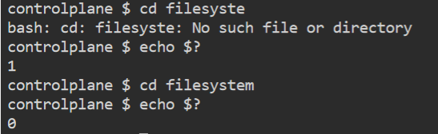

Suppose, we have a docker file with below conditions

From ubuntu CMD cd /home/echoume

Basic point to refresh:

1. What is default networking in Docker > Bridge
2. -w > watch, -o > output
3. Pod vs batch: Batch is the way to run the pod, if we run the pod with pod.yaml then restart policy may impact our work. So, if we are running pod as a part of batch then it will not restart.

Imperative Way to manage k8s objects

<https://kubernetes.io/docs/tasks/manage-kubernetes-objects/imperative-command/> for official docs  
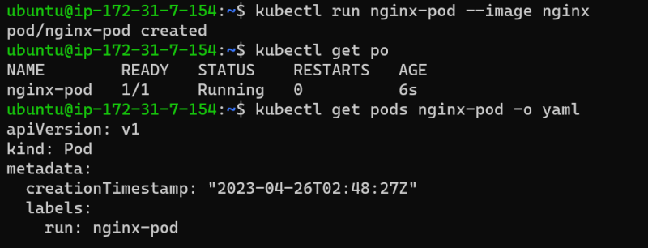

**Pod lifecycle**

* K8s Pods will have following states
  + Pending
  + Running
  + Succeded
  + Failed
  + Unknown

**Container States in k8s pod**

* Waiting
* Running
* Terminated
* <https://kubernetes.io/docs/concepts/workloads/pods/pod-lifecycle/#container-states> for container states
* IN pods we can specify container restart policy <https://kubernetes.io/docs/concepts/workloads/pods/pod-lifecycle/#restart-policy>

**Container restart policy**

* Let’s try to create a short lived contianer with different restart policies

always (Default)  
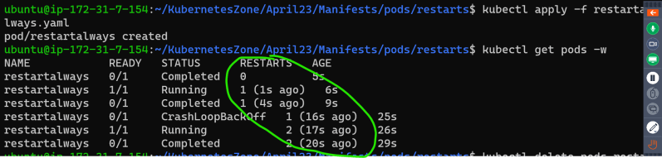

never  
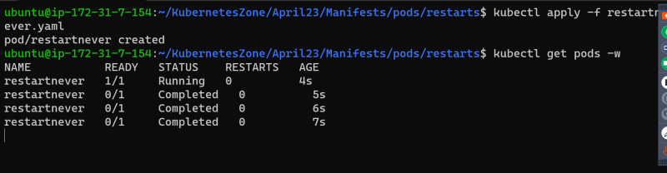

OnFailure exit code => success, exit code => failure  
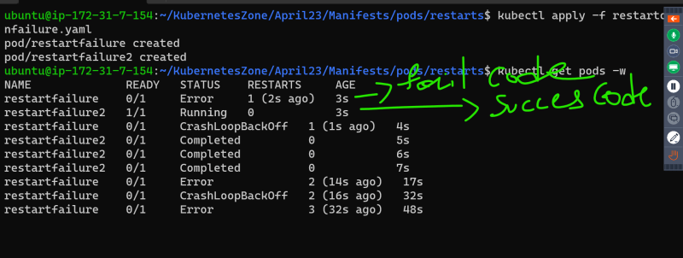

Manifest: <https://github.com/asquarezone/KubernetesZone/commit/f136484d376b15c1a984a6d3058cc33e51615709>

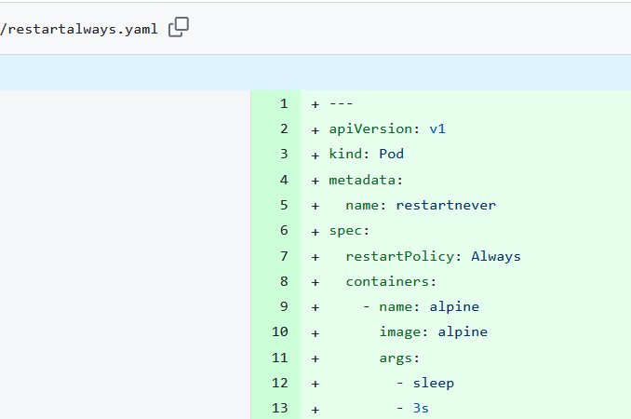

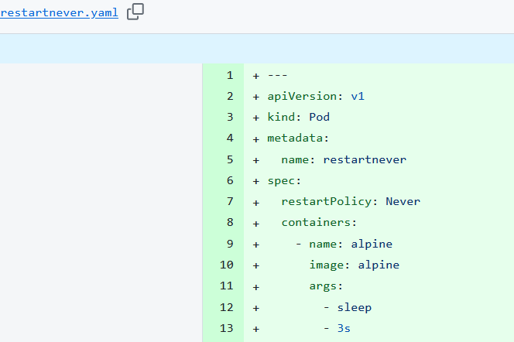

Crashloopbackup: Here container try to start itself in a loop.

